Assignment 3 — Cell-wise Notes
Iris data encoding, outlier detection, and predictive power score

Cell 0
Imports pandas and the label encoder tool.
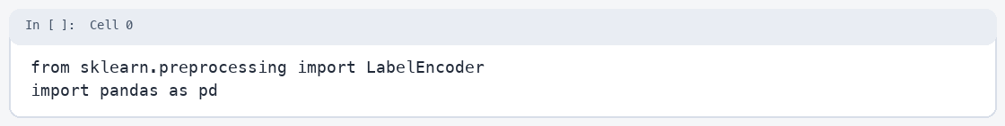

Cell 1
Loads the Iris dataset from iris.csv.
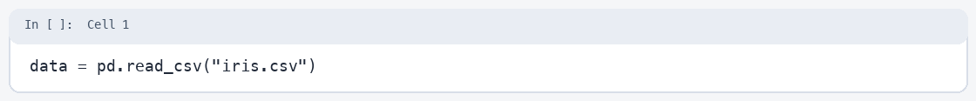

Cell 2
Displays the full dataset.
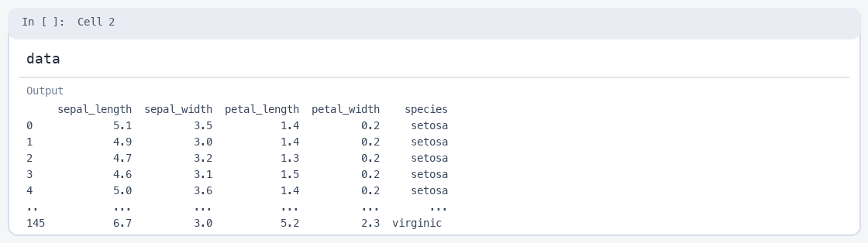

Cell 3
Shows the last few rows.
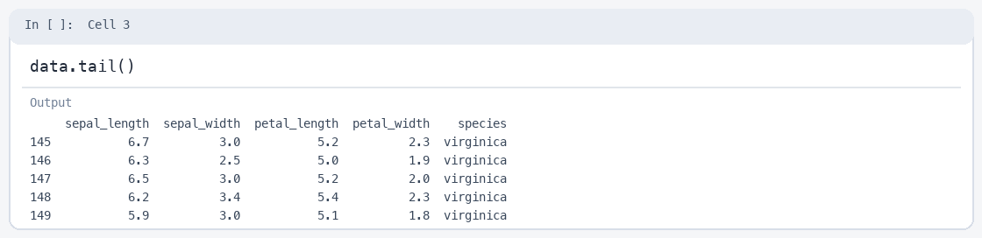

Cell 4
Shows the last few rows again.
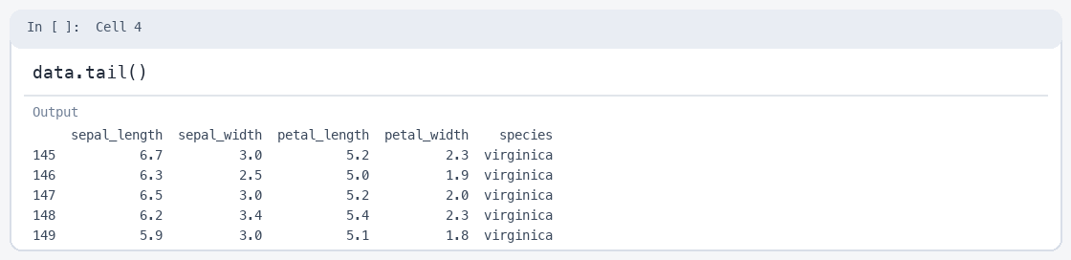

Cell 5
Displays column names, data types, and non-empty counts.
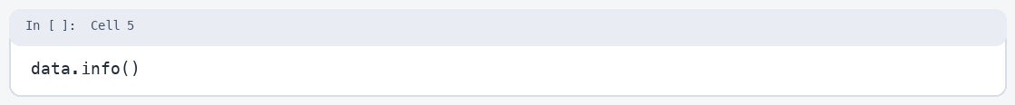

Cell 6
Summarizes numeric columns with statistics.
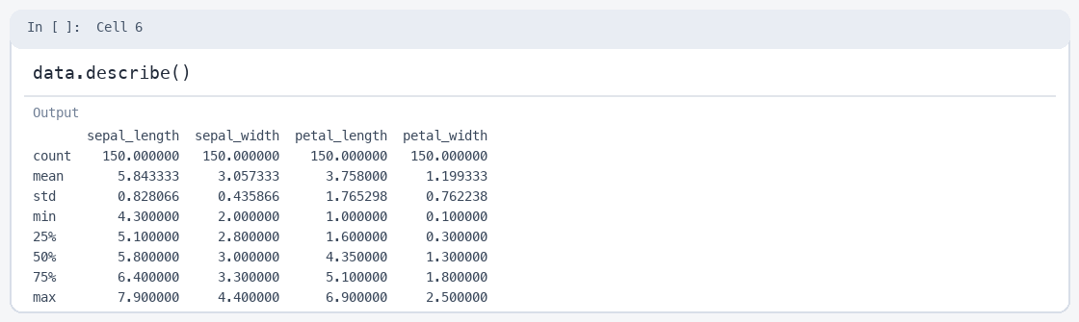

Cell 7
Notes that changes to a copy do not affect the original data.
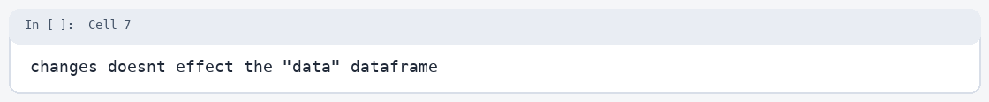

Cell 8
Makes a separate copy of the dataset.
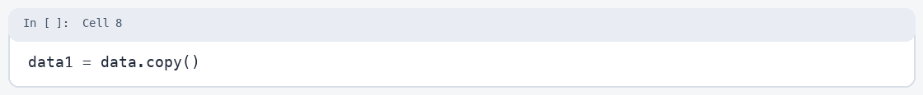

Cell 9
Shows commented-out label encoding examples.
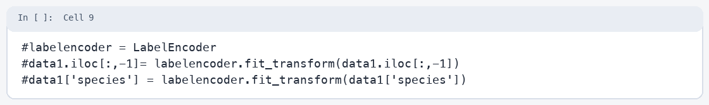

Cell 10
Converts species names into numeric labels.
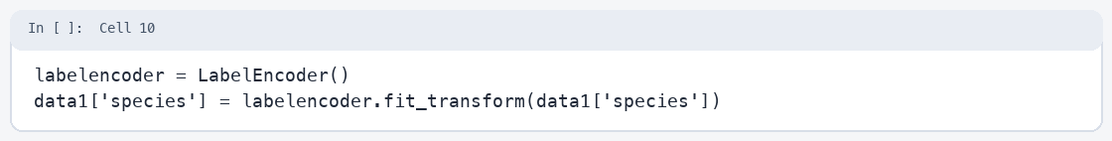
Quick example: species labels such as setosa, versicolor, and virginica become numeric values. One-hot encoding represents them with separate 0/1 columns.

Cell 11
Displays the dataset with encoded species values.
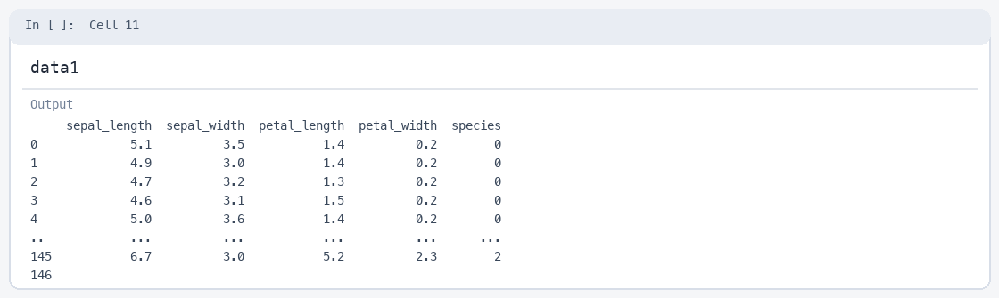

Cell 12
Shows species names and their assigned label order.
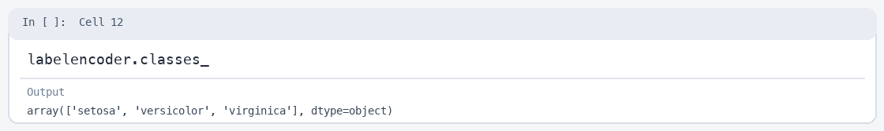

Cell 13
Imports the one-hot encoder.
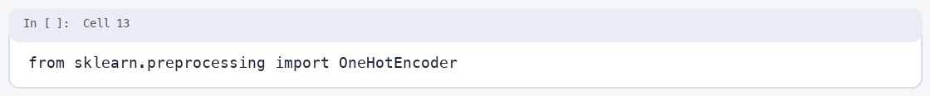

Cell 14
Loads a fresh copy of the Iris dataset.
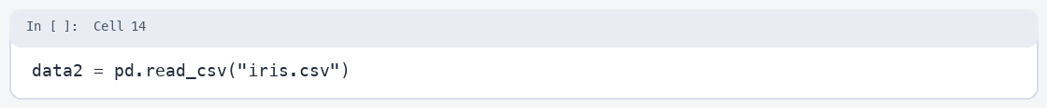

Cell 15
Displays the dataset.
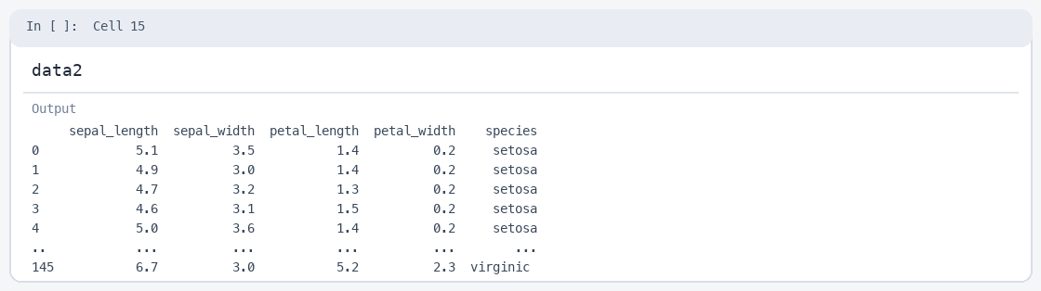

Cell 16
Creates a one-hot encoder.
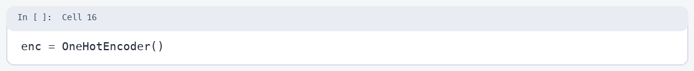

Cell 17
Converts species values into separate 0/1 columns.
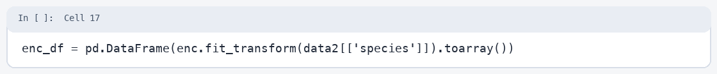

Cell 18
Displays the new species columns.
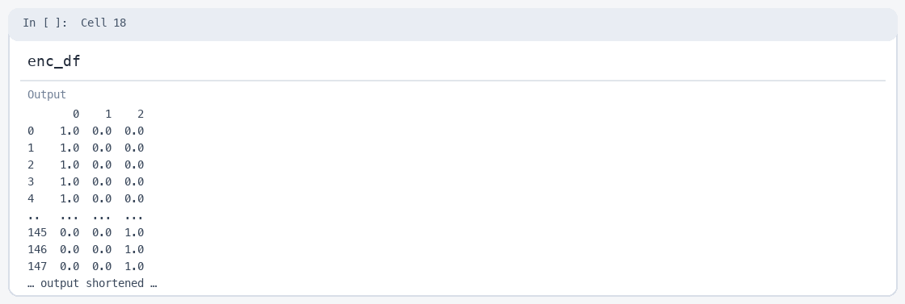

Cell 19
Joins the one-hot columns to the flower measurements.
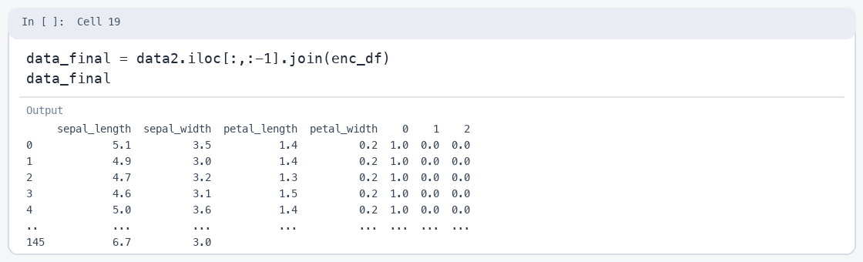

Cell 20
Imports pandas.
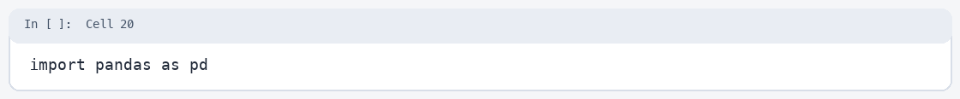

Cell 21
Loads the Iris dataset again.
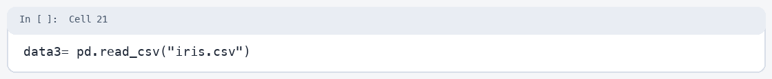

Cell 22
Converts text labels into 0/1 columns with get_dummies.
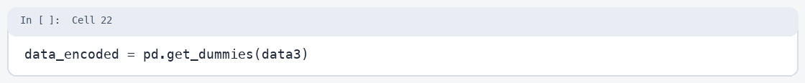

Cell 23
Displays the encoded dataset.
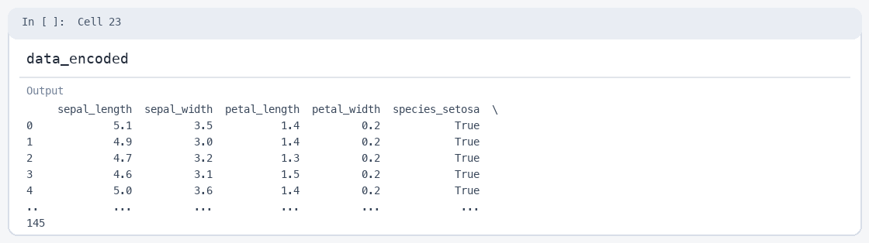

Cell 24
Imports Isolation Forest for detecting unusual rows.
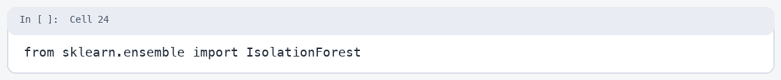

Cell 25
Loads the data and one-hot encodes the species column.
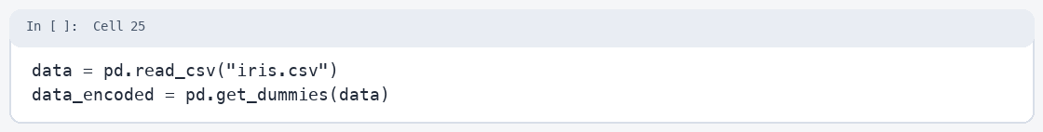

Cell 26
Displays the encoded data.
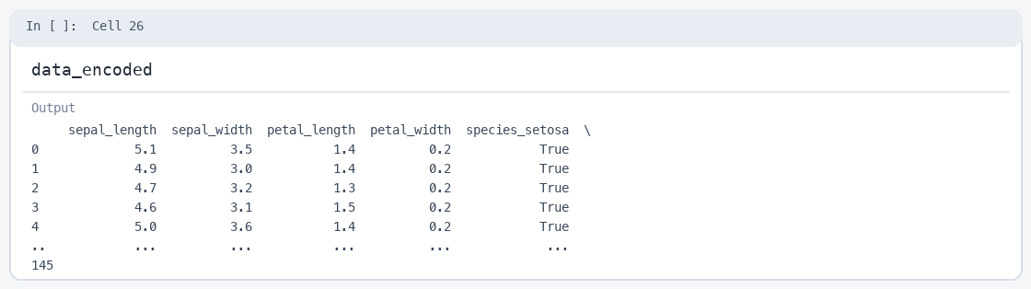

Cell 27
Fits an Isolation Forest with a 4% outlier setting.
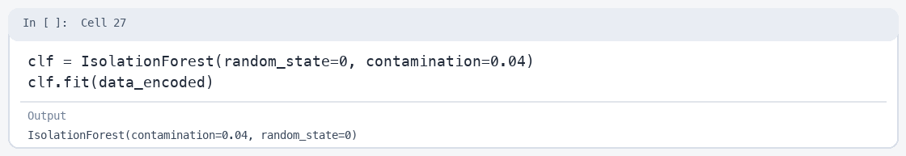

Cell 28
Predicts which rows look unusual.
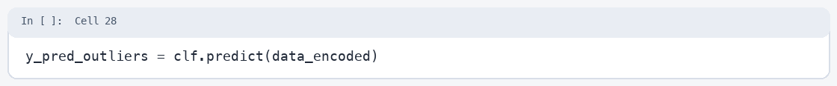

Cell 29
Displays predictions: -1 means outlier; 1 means normal.
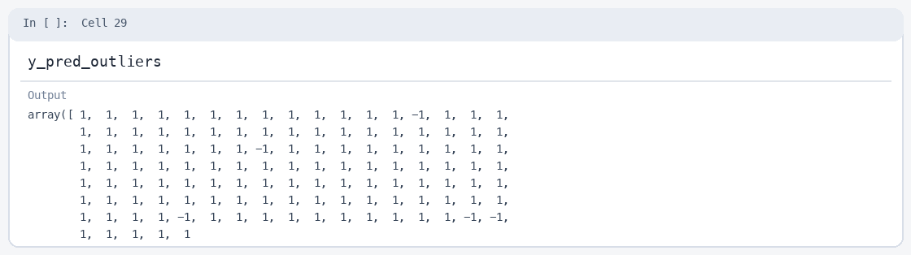

Cell 30
Displays the encoded data again.
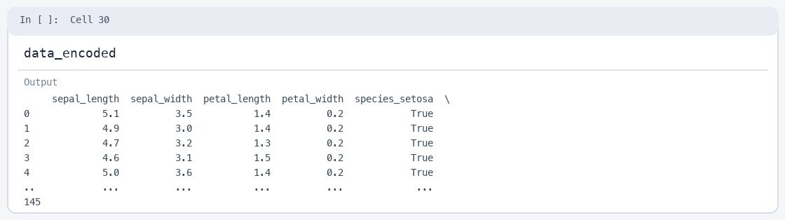

Cell 31
Copies the data to store anomaly labels.
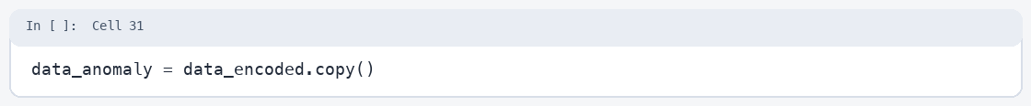

Cell 32
Adds an anomaly prediction to each row.
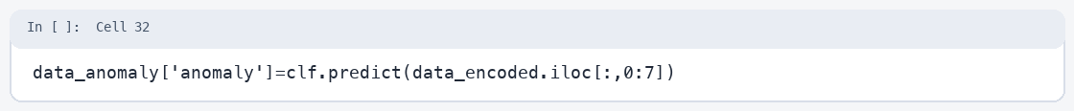

Cell 33
Displays rows with their anomaly labels.
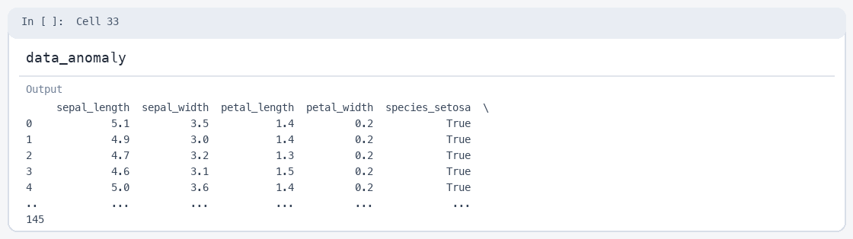

Cell 34
Shows only rows flagged as outliers.
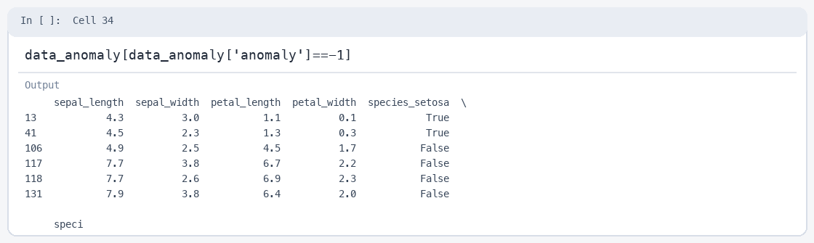

Cell 35
Calculates average flower measurements.
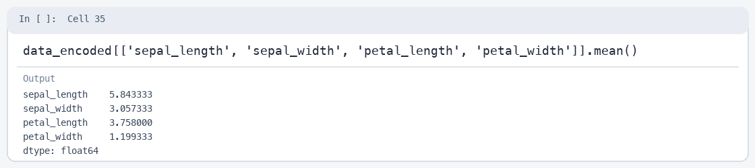

Cell 36
Adds a sample row with unusually large measurements.
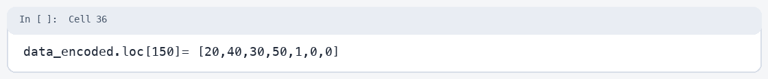

Cell 37
Refits the model using a 1% outlier setting and predicts again.
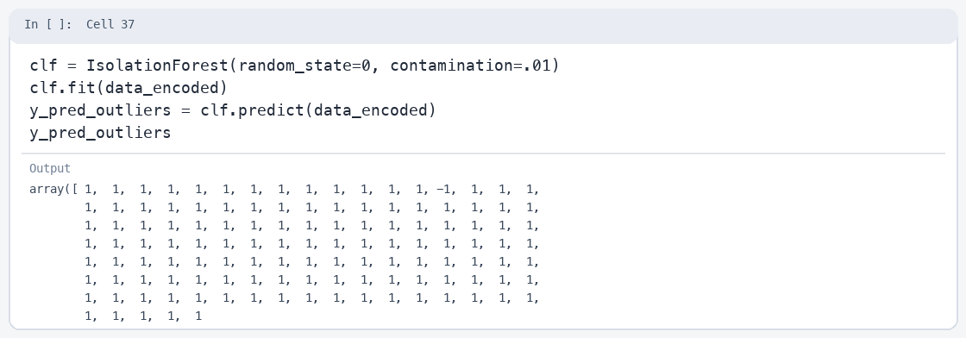

Cell 38
Adds an anomaly score; lower values indicate more unusual rows.
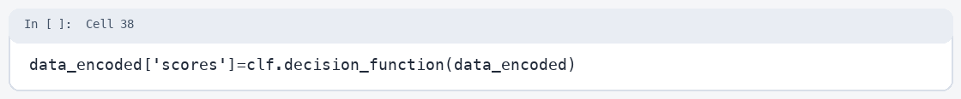

Cell 39
Adds a normal/outlier label to each row.
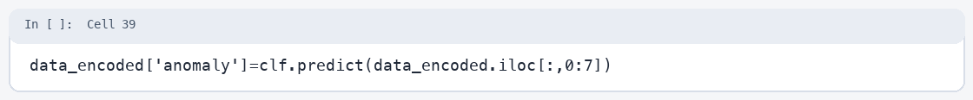

Cell 40
Displays the data with scores and labels.
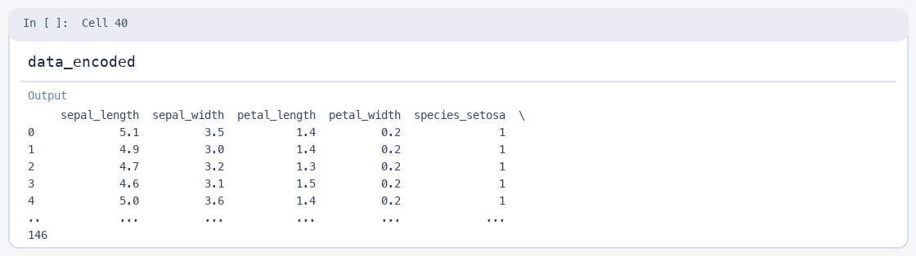

Cell 41
Shows only rows labelled as outliers.
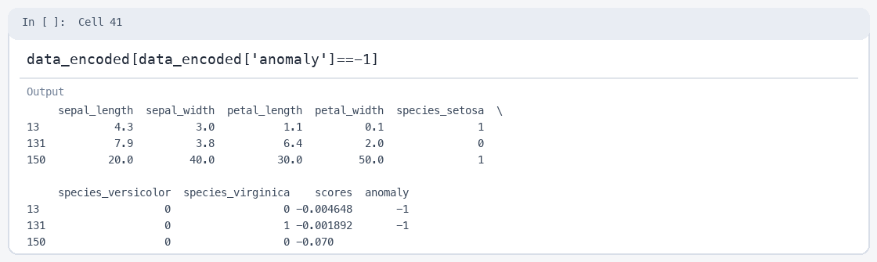

Cell 42
Recalculates average measurements, including the sample row.
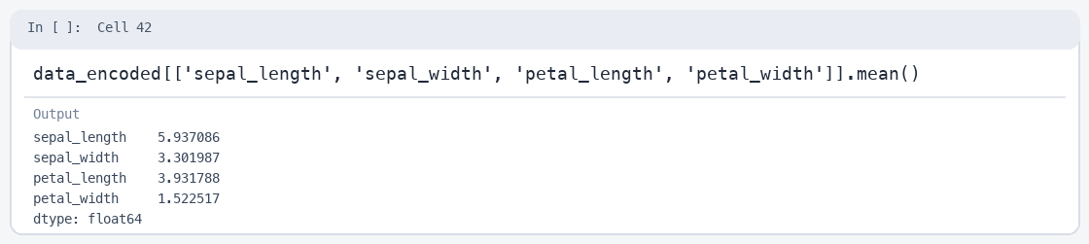

Cell 43
Installs ppscore for predictive power analysis.
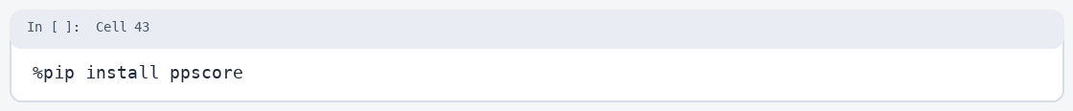

Cell 44
Imports ppscore.
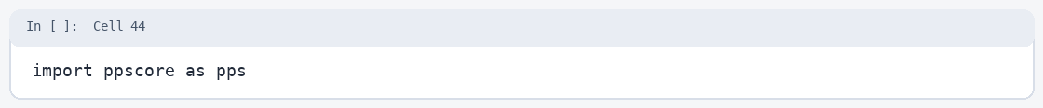

Cell 45
Displays the first few rows.
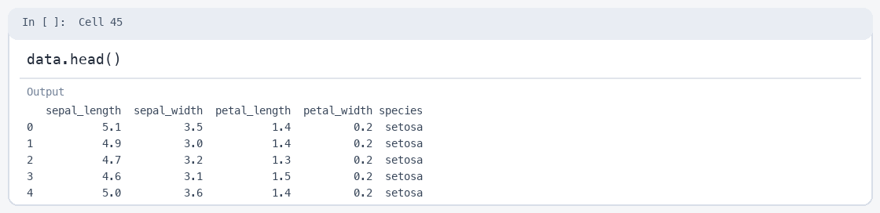

Cell 46
Checks how well sepal length predicts species.
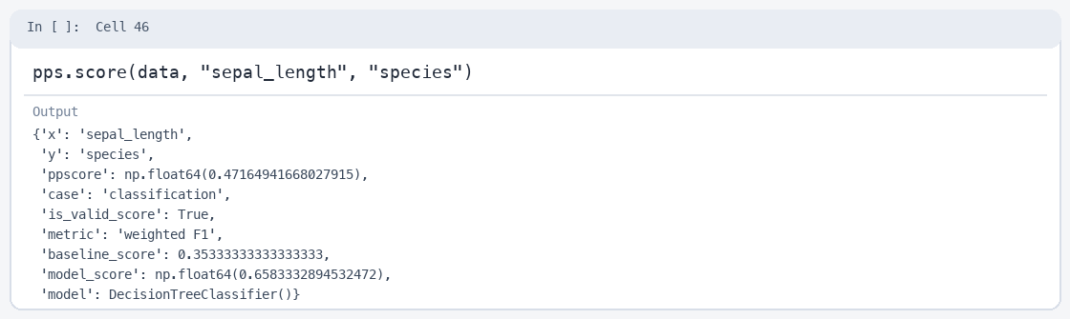

Cell 47
Calculates predictive power scores between columns.
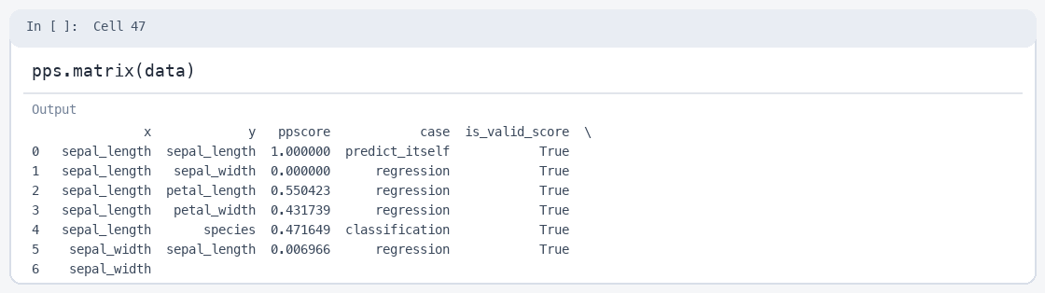

Cell 48
Displays the score matrix again.


